IMAGE MACHINE



Manual Guide Version 1.0

2022

Asep Saepudin

**CONTENTS**

1. Menu
2. List Data Machine.
3. Add Data Machine.
4. Delete & Update Data Machine.
5. Detail Machine.
6. Add Image Machine.
7. Full Screen Image.
8. Delete Image Machine.
9. Menu.

This application have two menu Data Machine.

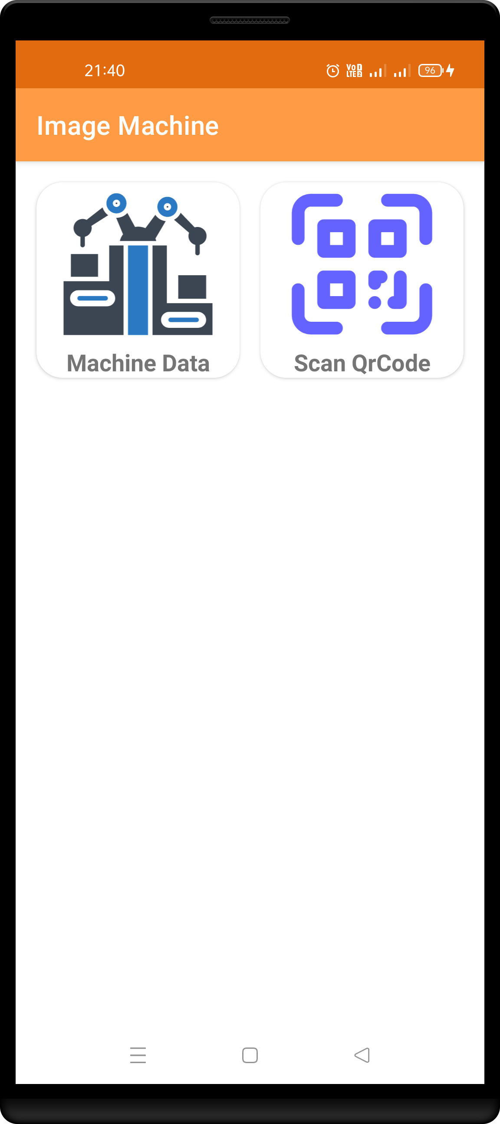

2

1

1. Machine Data.

Machine data have list data machine and user can input, delete and update data machine here.

1. Scan Qr Code.

User can scan Qr Code for check detail data machine.

1. List Data Machine.

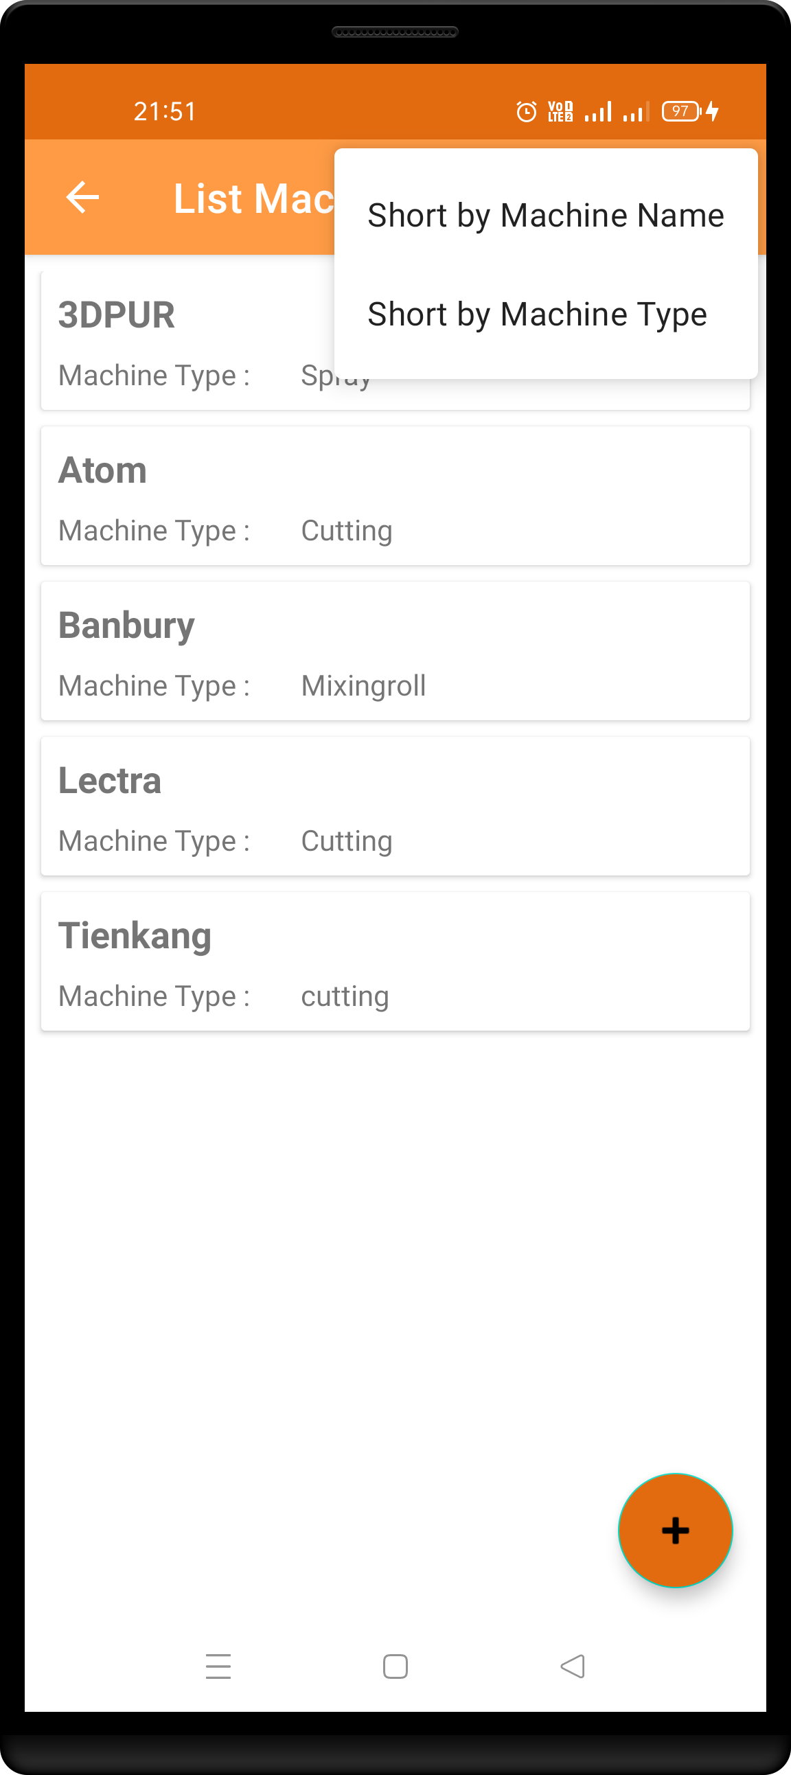

3

2

1. List Data Machine.

User can see all data machine here.

1. Short by Machine Name.

User can do shorting alphabeticaly by machine name.

1. Short by Machine Type.

User can do shorting alphabeticaly by machine type.

1. Add data machine.

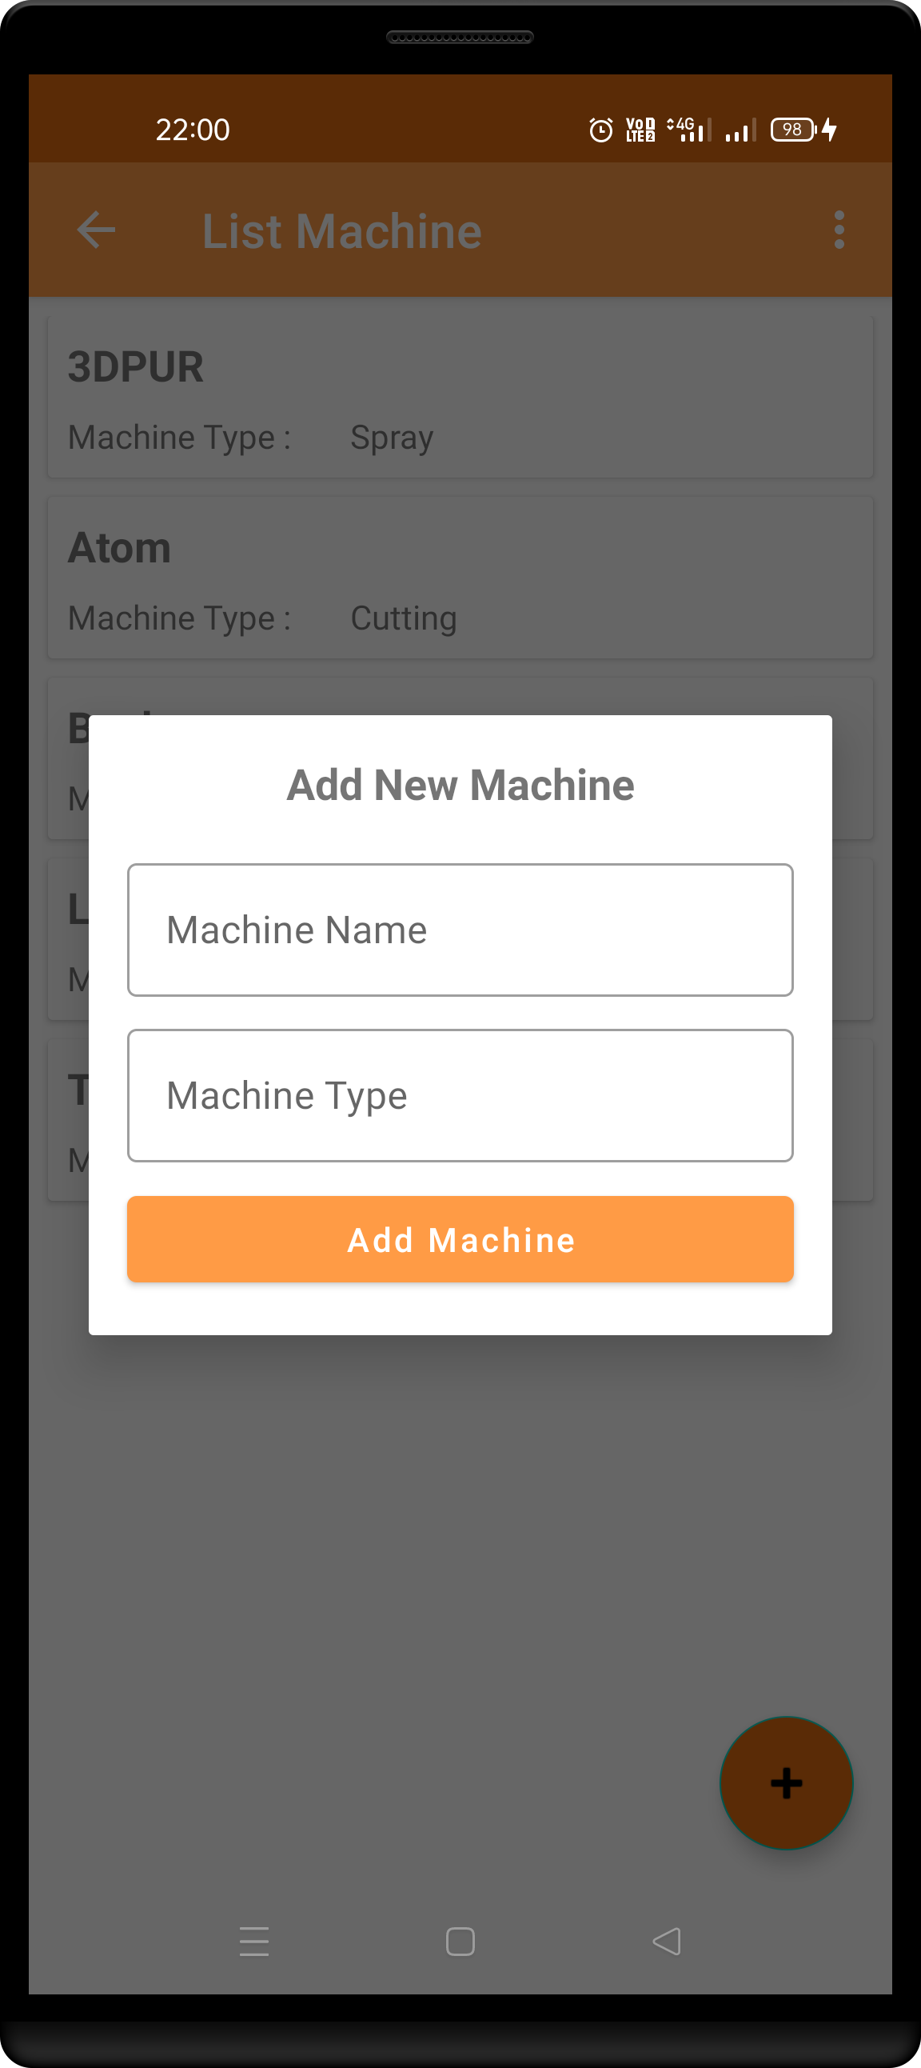

3

2

1. Click button for add new machine.

Application will show popup add new machine.

1. Fill machine name and machine type.

User must input machine name and machine type.

1. Add machine.

Click add machine for save data machine.

1

1

1. Delete and Update Data Machine.

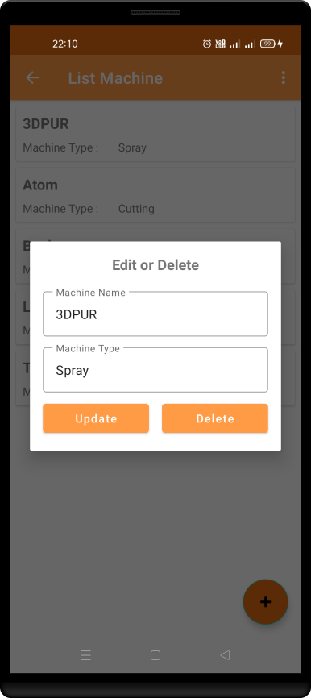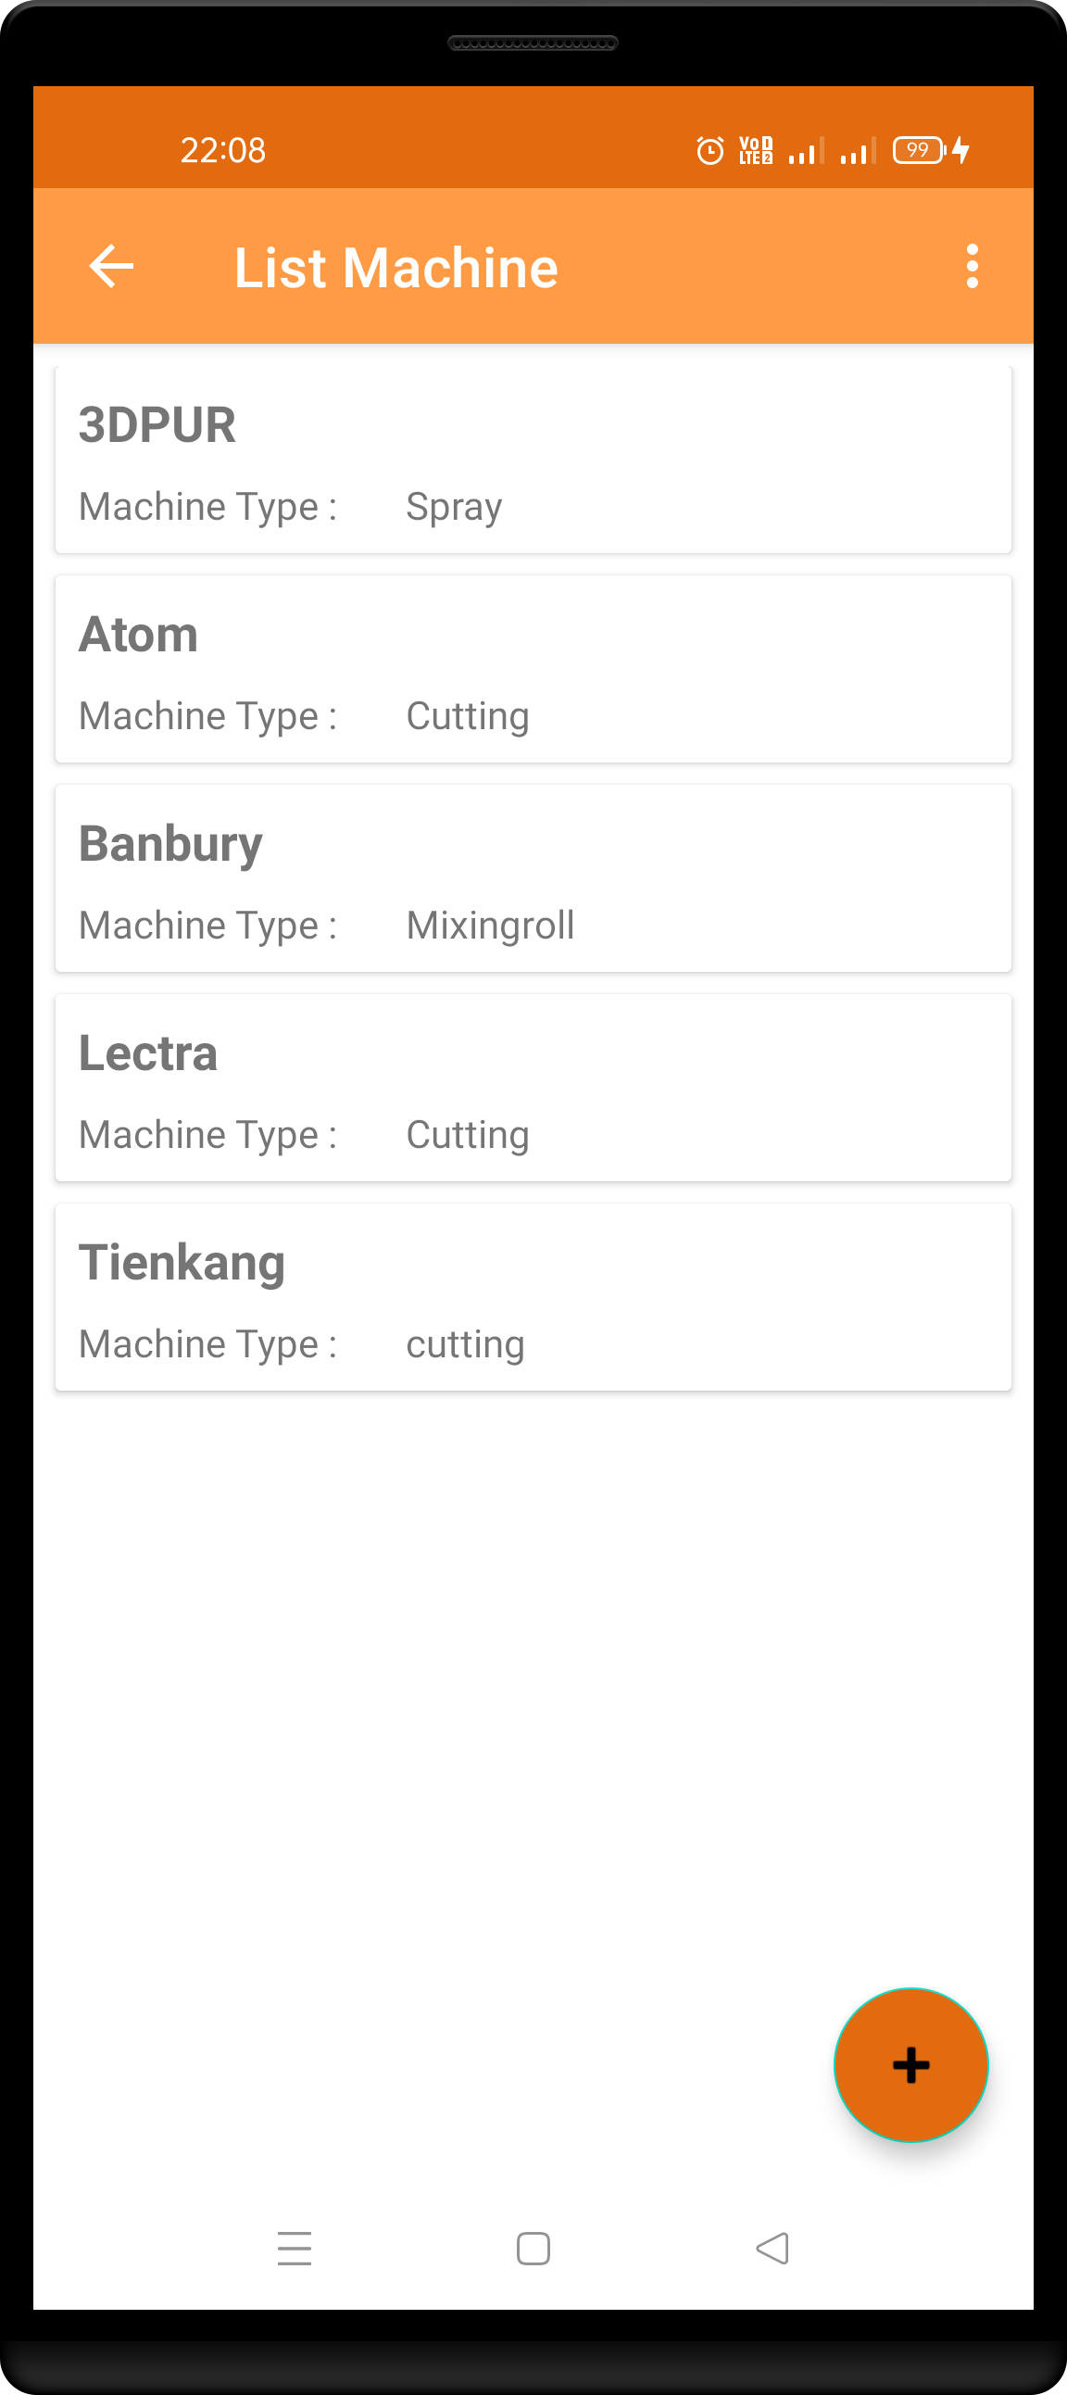

3

4

2

1. On Long Click here.

Application will show popup Edit or delete data.

1. Fill machine name and machine type.

User can change data machine here.

1. Update.

User can click update for save change data machine.

1. Delete.

User can delete data machine.

1

1. Detail Machine.

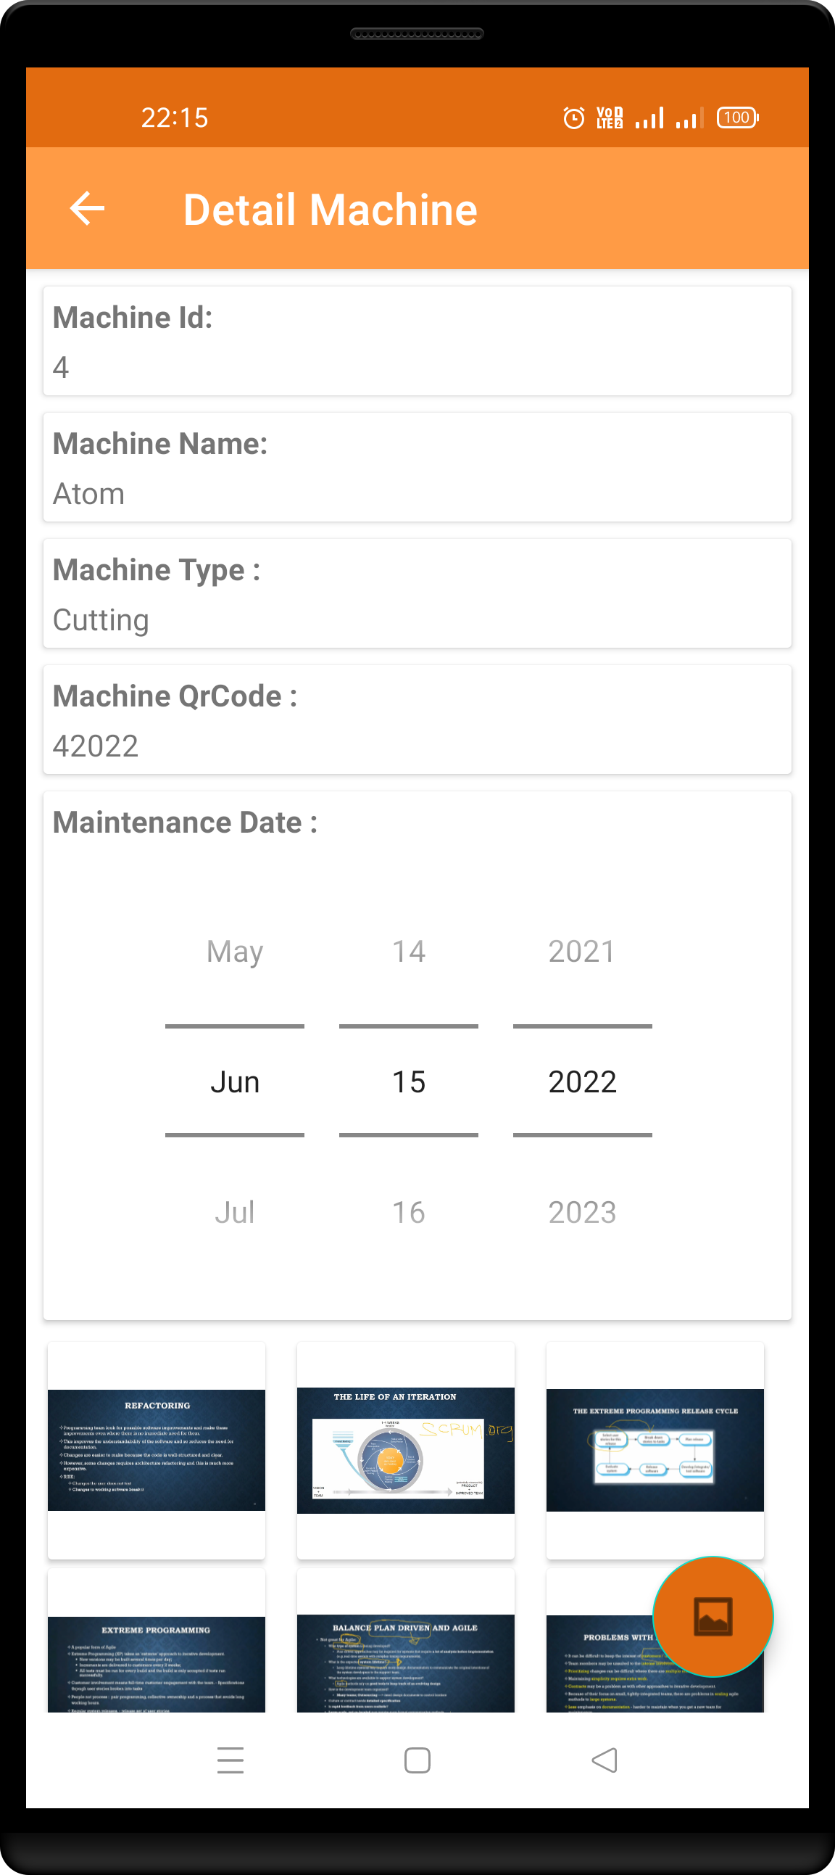

1

1. Detail Machine.

That is detail information about machine such as machine id, machine name, machine type, machine qrcode, maintenance date and image of machine.

1. Add Image Machine.

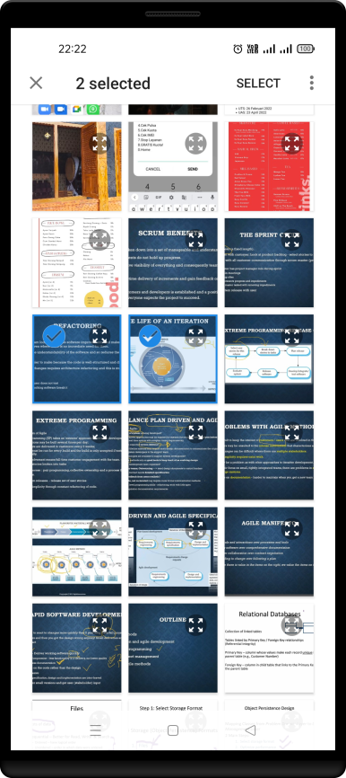

4

3

2

1. Click button add image.

That will open your gallery.

1. Choose item you want to add.
2. Select Counter will show here.
3. Click button select if you want to save image.

1

1. 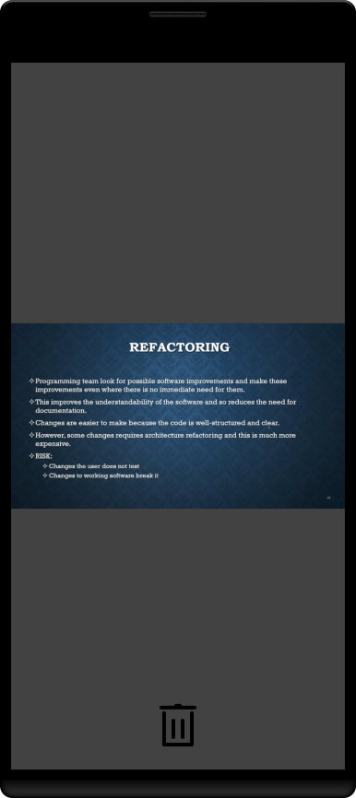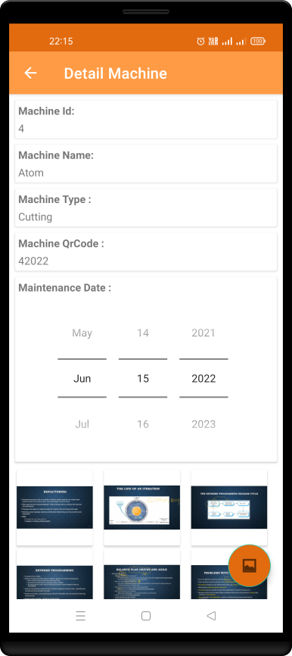Full Screen Image.
2. Choose image you want to see mode full screen.

That will open your gallery.

1. Image will show full screen.

2

1

1. Delete Image Machine.
2. Click button delete it will delete image on database.

1

Thanks